Cheap wine and cheese puffs are only the beginning of this ‘Happy Hour’
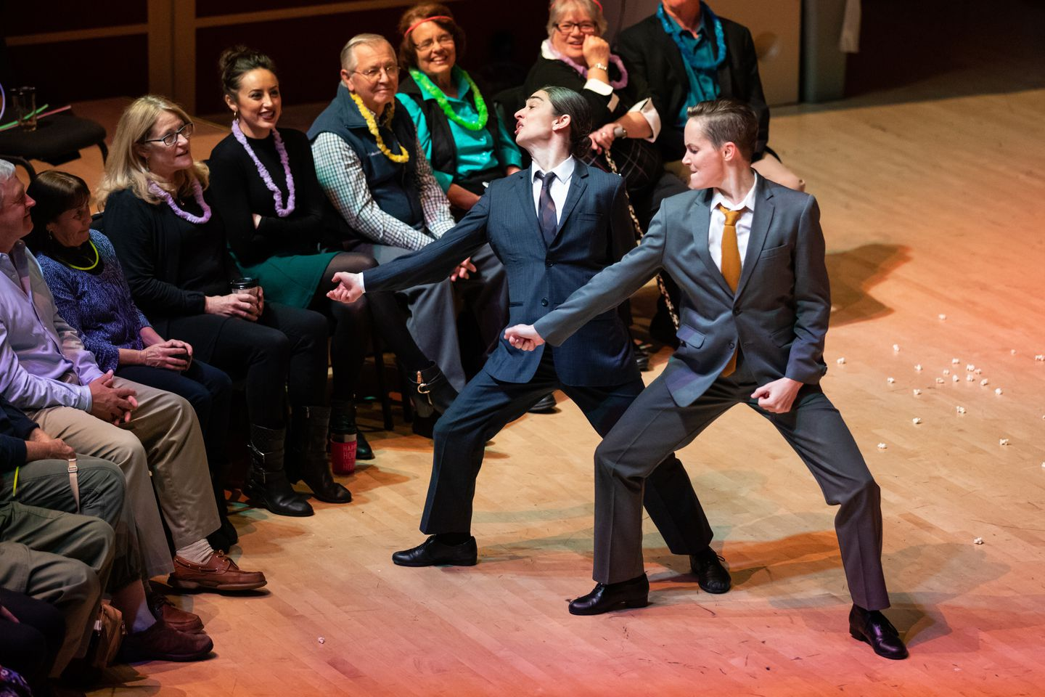

Monica Bill Barnes, left, and Elisa Clark captured the stereotypical male essence in their performance of “Happy Hour.” (Brennan Spark/The Clarice Smith Performing Arts Center)

By Sarah L. Kaufman
Dance critic
November 22, 2019 at 3:10 p.m. EST
Link: https://www.washingtonpost.com/entertainment/theater_dance/cheap-wine-and-cheese-puffs-are-only-the-beginning-of-this-happy-hour/2019/11/22/71e582c4-0d3b-11ea-a49f-9066f51640f6_story.html
Monica Bill Barnes & Company’s “Happy Hour” offered the audience cheap wine, cheese puffs and karaoke. But the party really got started when two women dressed as men crashed it.
The crowd was in a festive mood by that point on Thursday night in the intimate second-floor performance space at MilkBoy ArtHouse in College Park. The room was hung with streamers and balloons; an emcee was hawking raffle tickets and snacks. Suddenly the women in suits and ties entered with such crisp, swaggering authority that all conversations ended and the audience snapped to attention.
Janet Jackson hired her as a backup dancer. Instagram made her a star.
Part dance performance, part vaudeville act, “Happy Hour” was a ripsnorting laughfest because of a beautifully balanced gender tension: The dancers’ hypermasculine mannerisms were eerily precise and yet they were aspirational, touched with longing. Barnes, with her dark hair in a bun, and willowy Elisa Clark, with a sleek pompadour, are both delicately built, but with their shoulders thrown back, jaws clenched and fists crammed in pockets, they presented a hilarious portrait of toxic masculinity on the hunt for sexual conquests.
Mark Morris bares his soul in a refreshing raw and inspiring memoir
The comedy was in the spot-on perfection of their quick nods and chin signals to one another, communicating their thoughts about audience members in a silent “male” code we could all read: I’m going for her; no, she’s mine; back off, I saw her first. One game young woman seated in the front row was coaxed to the center of the floor, where she was fussed over and flirted with in a calculated escalation of behaviors that in any other setting would have us cringing or calling security. Here, however, Barnes and Clark shaded their strutting with such earnest desperation that the scene became a metaphor for the vulnerability and social awkwardness in all of us.
On a cold night, Ronald K. Brown/Evidence offers the balm of human warmth
“Happy Hour,” part of the Clarice’s Visiting Artist Series, is just that: a happy hour, short, sweet and ultimately poignant. What emerged was a comedy of bad manners. Clark, whose experience includes stints with Alvin Ailey American Dance Theater and Mark Morris Dance Group, fished a wad of gum out of her mouth and plastered it on the fire extinguisher. They flipped their ties over their shoulders and played air guitar and air drums to hyper-male recordings such as Journey’s “Any Way You Want It.” At one point they lip-synced the sugary “Build Me Up, Buttercup” to a woman in the back row, turning it into a beseeching cry of neediness through their mimed delivery.

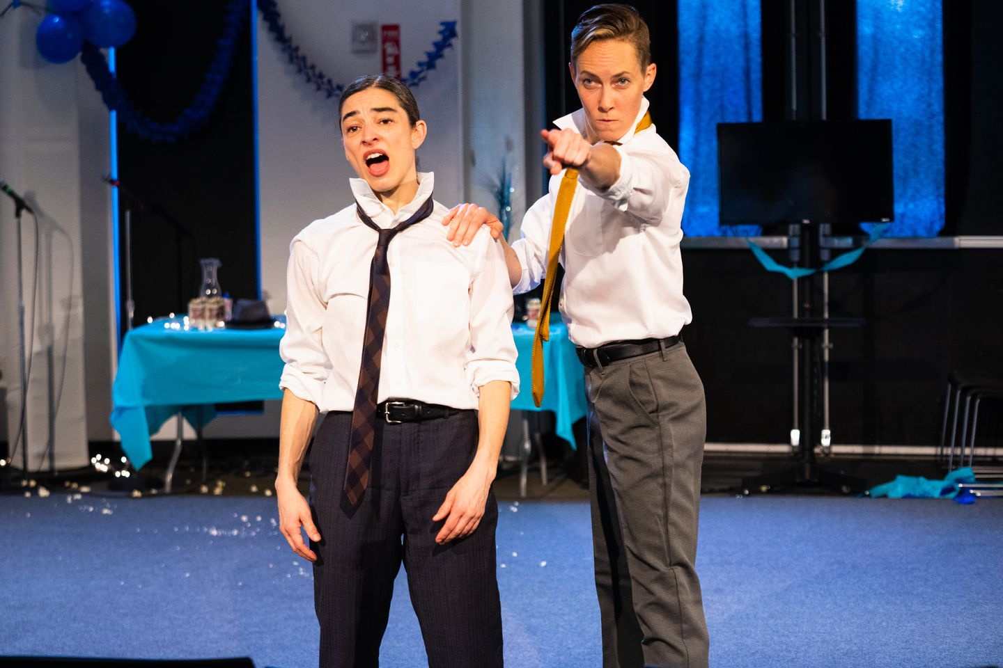

The pair donned suits and ties for the performance. (Robert Torres/The Clarice Smith Performing Arts Center
)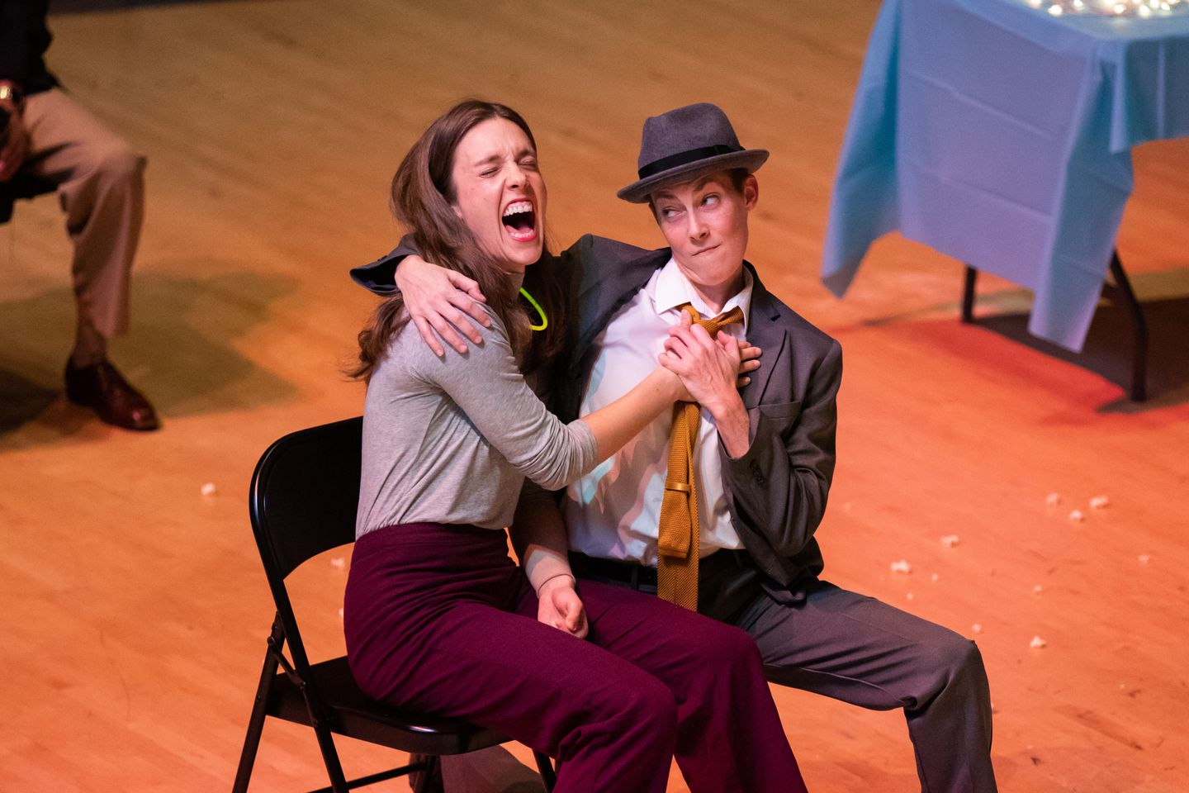

Clark and an audience member. (Brennan Spark/The Clarice Smith Performing Arts Center)

Taking on characters and interacting directly with the audience are hallmarks of Barnes’s work. She created “Happy Hour” in 2015 with company members Robbie Saenz de Viteri (he was the genial emcee, pushing drinks and snacks on the audience before the dancers entered) and Anna Bass. It arose, to quote the company’s motto, from a desire to put dance where it doesn’t belong.

“It’s dance missionary work, introducing dance to people who don’t normally see dance,” Saenz de Viteri said in a question-and-answer session after the show. In previous works such as “The Museum Workout,” Barnes and her collaborators sweep patrons along with them in a choreographed exercise routine through galleries. In “Three Acts, Two Dancers, One Radio Host,” they teamed up with “This American Life” radio host Ira Glass in live performances that turned radio stories into dance.
“Happy Hour” arose at a perfect time, combining Barnes’s interest in male behavior in the workplace with the cultural spotlight on it as the #MeToo movement grew. But the show is more universal than that, she said. She was inspired by karaoke, and how in singing along to songs by our idols, “we always fall short of who we emulate.” As any comedian and storyteller knows, and as Clark and Barnes make brilliantly clear in “Happy Hour,” failure can get us right in the gut, and the heart.

Monica Bill Barnes & Company’s “Happy Hour” will be performed Friday at 8 p.m. at MilkBoy ArtHouse, 7416 Baltimore Ave., College Park. 240-623-1423. milkboyarthouse.com.

