MIDDLE WESTERN (working title)
stories from the middle

Manual Cinema and Third Coast Percussion are collaborating to create a new touring piece with working title Middle Western. Premiering in summer or fall 2021 and available for tour dates in the 2021/2022 season, we are actively seeking co-commissioning support, workshopping partners, and presenters.

In the popular imagination, the American Midwest has always been hard to pin down. It has been called flyover country, the heart of America, the first stop, the last resort, the most ‘American’ part of America, and home to various peoples for tens of thousands of years. From the outside, its boundaries, borders, and significance shift in the wind - but the Midwest has concrete and universal stories to tell. In light of the future of the region - specifically in the context of climate change - these stories take on new significance. The American Midwest and its particular stories offer new ways of thinking and reimagining. Middle Western aims to tell some of those stories, traversing time and space to trace the interconnectedness of people, natural systems, place, and history.

Middle Western is designed as a concert with live visuals—with music composed and shadow puppetry/live visuals created by Emmy award-winning multimedia company Manual Cinema, and with a score performed by GRAMMY award-winning percussion quartet Third Coast Percussion (both Chicago based organizations). The organizing structure of the piece is a collection of short stories — both narrative and non-narrative shorts of varying lengths, subject matters, and points of view — all related to the American Midwest. The stories will be written by Manual Cinema Artistic Directors, as well as outside writers, scientists, and citizens of the Midwest. The various vignettes will take place in a range of time periods (including the future) and will be told from many perspectives (people, plants, buildings, geological features, etc). Individual stories will be grouped in pairs, trios, or sequences to bring out juxtapositions, resonances, and poetry (e.g. a story of old-growth tree logging followed by a story from the perspective of an invasive plant species).

Despite this range of stories and storytelling, there are several themes that bring form and structure to the piece. Migration and adaptation, at the center of so much of the Midwest’s history, will be major thematic motifs, represented by a range of stories, from glacial melt to the Great Migration to Great Lakes invasive species.

As North America warms in the coming century, the Midwest’s relatively temperate climate and access to the largest fresh water system on the planet make it a likely candidate for what could be the largest climate-related mass migration the continent has ever seen. A central, running storyline will be devoted to a newly arrived climate refugee in the not so distant future and how a return to Native American respect for natural systems could provide a way forward for a society on the brink.

SAMPLE STORY IDEAS:
- a story told from the perspective of the glacier that created the great lakes
- a story told from the perspective of a tree in rural Wisconsin being logged in the early 20th century after hundreds of years of growth
- a story told by a child in the year 2199 when climate refugees from around the world flood the Midwest for the freshwater and a livable climate
- non-narrative piece on vogueing in Detroit and Chicago in the 1990’s*
- Non-narrative piece about maps + boundaries*
- a story told from the perspective of an indigenous family migrating thousands of years before European settlers arrived**
- a short based on the circular flow of water in Lake Michigan
- a story about a family moving to a Midwest city (likely Chicago or Detroit) during the Great Migration*
- non-narrative piece on cloud formations common in the Midwest
- a story told from the perspective of a Century of Progress home
- a story told from the perspective of an invasive species of plant

*we will be working with expert scientists, naturalists, writers, and artists with first hand knowledge of the subject matter to tell these stories
** we will be working with Native American artists to tell this story

REFERENCES/ INFLUENCES:
- Florida (book of short stories) by Lauren Groff
- The Overstory (book of short stories, recent Pulitzer winner) by Richard Powers
- Madame Zero (book of short stories) by Sarah Hall
- The Tree of Life (film) by Terrance Mallick

MEDIA:

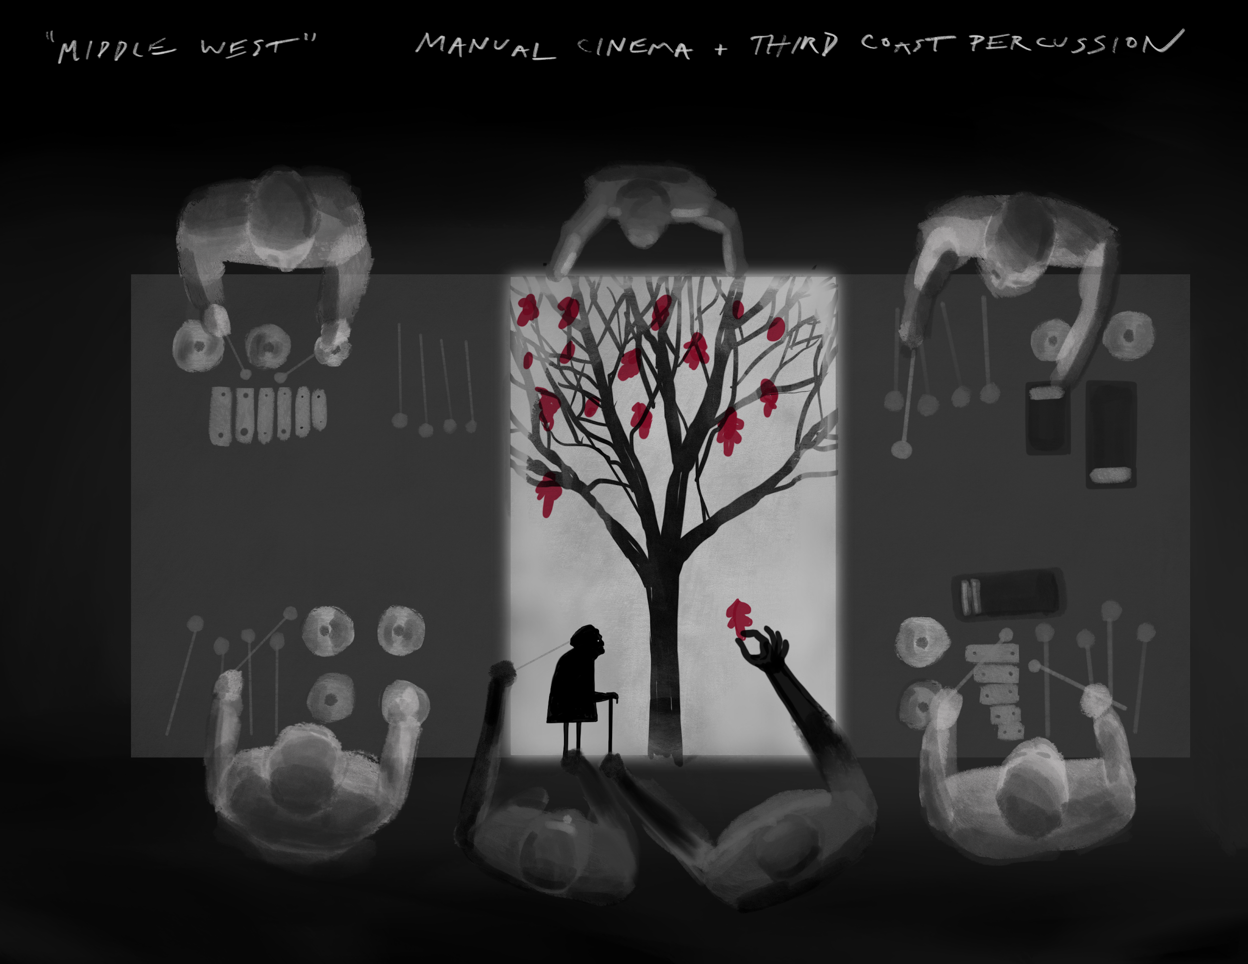
The concept sketch above shows a live feed video table top setup that would include live percussion performance and shadow puppetry integrated into one frame projected onto a large screen or scrim above the stage. The show would likely include 2-3 live feed visuals/ music performance setups like this.

Video and audio recordings by Third Coast Percussion can be found here: http://thirdcoastpercussion.com/look-and-listen/audio-and-video/

Audio recordings of Manual Cinema composers Kyle Vegter and Ben Kauffman can be found here: https://manualcinema.bandcamp.com/

More information, photos, and video of Manual Cinema’s work can be found here: http://manualcinema.com/

TOURING ENGAGEMENTS AVAILABLE IN THE 21/22 SEASON:
Middle Western will tour with a total of 8 people: 4 percussionists, 3 puppeteers, 1 staff/crew. Fees will start at $22,000 plus housing for a single performance.

CONTACT:
The Middle Western team is actively seeking co-commissioning support, workshopping partners, and presenters. We aim to premiere the piece in summer or fall 2021, and it will be ready to tour in the 21/22 season. All inquiries should be directed to:

Elsie Management
Laura Colby, Director
laurac@elsieman.org
TEL: +1 718 797 4577

